**The correlation of the normalised data for some selected cell lines with the 10 centroids**

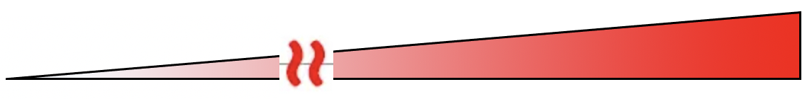

**ZNF703 expression**

|  |  |  |  |  |  |  |  |  |
| --- | --- | --- | --- | --- | --- | --- | --- | --- |
| **BCCL** | ZR751 | MCF7 | BT474 | MFM223 | CAMA1 | HCC1500 | BT483 | MDA-MB-134VI |
| **IntClust assigned (combined classifier)** | 8 | 1 | 5 | 3 | 6 | 6 | 8 | 2 |



The above cell lines were picked as they are currently being worked on by Allan. In general, the IntClust with the maximum correlation is similar to the one I have assigned, but you could see that the next best/second best correlation score (in red box) for the positive controlled cell lines corresponds in IntClust 6, suggesting that the normalised data for these 3 cell lines (in which Feung believed should be assigned to Intclust 6) also correlate well to Intclust 6 centroid.

**Positive controls (ZNF703 amplified):**

MDA-MB-134

HCC1500

BT-483

CAMA-1

MFM-223

**Negative controls (ZNF703 copy number neutral):**

MCF7 (known to be luminal)

ZR-75-1 (known to be luminal)

BT-474 (known to be HER2+)

